**AUGUST 1914 - SHOULD BRITAIN FIGHT?**

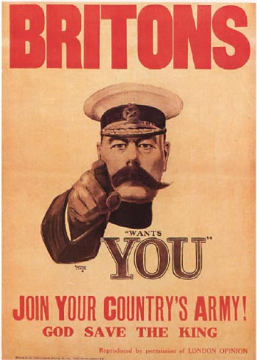

This week I would like you to design a poster, for classroom display.

It is August 1914. Should Britain enter the Great War, and declare war on Germany and her allies? Or should Britain stay neutral – not bother to get involved?

Design a poster to **persuade** the British public why Britain must enter the war against Germany, or why she ought to stay out of the Great War. It needs to be eye-catching and have strong messages, for or against Britain entering the War.

**Things to consider**

Britain has been concerned about the **growing power of Germany** for some time. Germany is a threat to Britain in many ways – she is a new country who is challenging Britain’s empire, her navy and her industry and wealth. Germany’s growing power can only be at Britain’s expense. There is a lot of anti-German feeling in Britain by 1914.

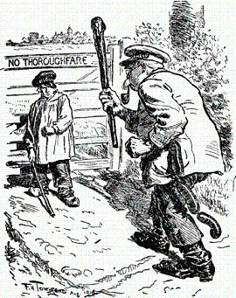

By invading neutral **Belgium** on 3rd August 1914 Germany has broken the terms of **The Treaty of London (1839)** which guaranteed Belgium’s independence and neutrality– a treaty which Britain signed. As a matter of honour, shouldn’t Britain defend Belgium’s neutrality and independence from German aggression?

Also, Germany is attacking **France** – and France is Britain’s ally under the **Entente Cordiale (1904)** and the **Triple Entente (1907).** Britain has a 100,000-strong professional army, the British Expeditionary Force (BEF), ready to send to France should she be attacked. If Germany humiliates France with a quick victory then Germany would become very powerful indeed – a worrying development for Britain. A German attack on Russia is likely to follow. Where will German aggression stop?

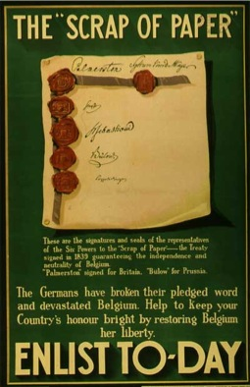However, Germany’s quarrel in 1914 appears to be with Russia, for supporting Serbia against Austria, and against France. It is not clear that Germany wants war with Britain. Germany is an important trading partner of Britain, and a defeat in war against Germany might damage Britain’s empire, navy and wealth. Germany’s army (2.2 million men) is vastly bigger than that of Britain (711,000). Britain stayed out of previous wars between France and Germany – like the Franco-Prussian War (1870-71). Perhaps it should do the same in 1914?

Some people in Britain are known to be against war with Germany. Some are **pacifist** – they believe the very idea of war and killing is wrong. Others believe the war will be a **bosses’ war** – factory owners will make big profits from selling weapons, whilst the victims will be workers and ordinary people.

The outbreak of war might also be dangerous for Britain in 1914. The mood of the country is already angry. There is civil war looming in Ireland. Some women – known as suffragettes - have been conducting a violent campaign to gain the vote. Workers have been going on strike in record numbers. War might spark a violent **revolution** in Britain.

**What do YOU think? Should Britain go to war in August 1914?**